Unit 1 test
Vocabulary
Vocabulary
1 Look, read and write the letter.
 | 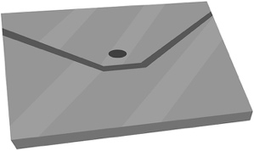 | 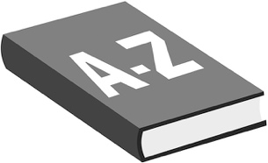 |  | dictionary  glue stick  pencil case  folder  water bottle  scissors
1 | 2 | 3
 |  | 
4 | 5 | 6
/ 6
2 Look and tick ().
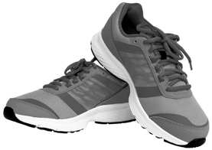 | 1 A ☐ football boots  B ☐ trainers
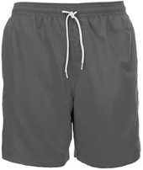 | 2 A ☐ shorts  B ☐ tracksuit
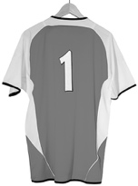 | 3 A ☐ football shirt  B ☐ sports bag
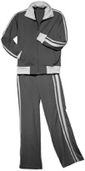 | 4 A ☐ trainers  B ☐ tracksuit
/ 4

Grammar
3 Look, read and circle.
 | 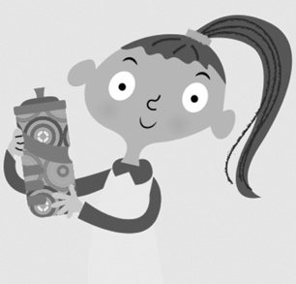 | 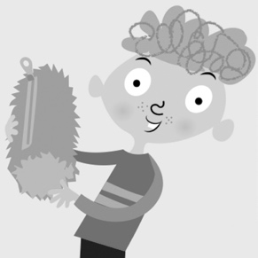
1 Have you got  a lunch box?  Yes, I have. /  No, I haven’t. | 2 Has she got a folder?  Yes, she has. /  No, she hasn’t. | 3 Has he got  a pencil case?  Yes, he has. /  No, he hasn’t.
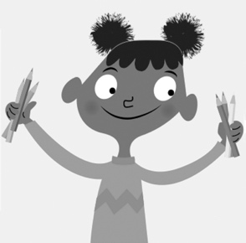 | 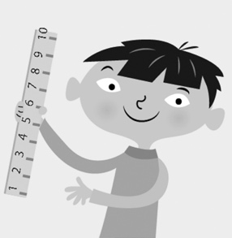 | 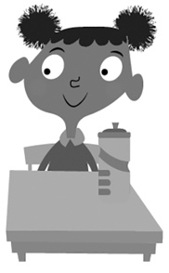
4 Has she got pencils?  Yes, she has. /  No, she hasn’t. | 5 Has he got  a dictionary?  Yes, he has. /  No, he hasn’t. | 6 Have you got  a water bottle?  Yes, I have. /  No, I haven’t.
/ 6
4 Read and tick ().
1 We’ve got … ball – let’s play!
A ☐ our B ☐ their
2 It’s football club today. They’ve got … shorts.
A ☐ our B ☐ their
3 It’s time to play. … got our football boots.
A ☐ They’ve B ☐ We’ve
4 They’re ready to play. … got their trainers.
A ☐ We’ve B ☐ They’ve
/ 4
Reading
5 Read and circle T (true) or F (false).
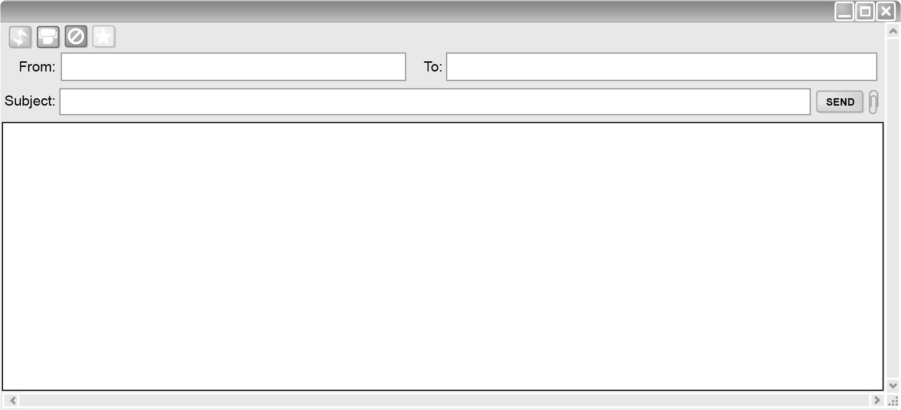
Ismini Gurdeep
My school
Hi, Gurdeep!
This email is about my school. My school is in Westville. My school has got blue windows and a yellow door. In Westville, lots of schools have got football teams. My school has got a football team, too. They’ve got football boots and football shirts. My classroom isn’t big.
I’m happy today because it’s Monday. I’ve got an art lesson today! We’ve got scissors and glue sticks. We’ve got crayons, too! We can make a good picture! It’s a football game!
There are two teams in the picture. Have you got crayons? You can make a picture, too!
Write soon,
Ismini

1 The email is about Ismini’s school. T / F
2 The school is in Westville. T / F
3 The school has got yellow windows. T / F
4 The classroom is big. T / F
5 The picture has got two teams. T / F
/ 5
Writing
6 Rewrite the sentences.
1 this is my school
2 it’s got a yellow door
3 they’ve got football boots
4 my classroom isn’t big
5 it’s got five desks
/ 5

Listening
7  1 What has Nia got? Listen and circle Y (Yes) or N (No).
 |  | 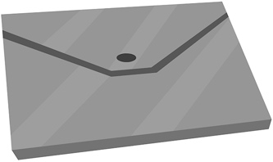
1 Y / N | 2 Y / N | 3 Y / N
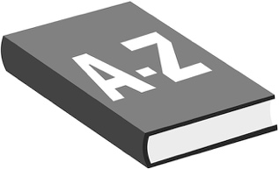 | 
4 Y / N | 5 Y / N
/ 5
Speaking
8 Look, read and answer.
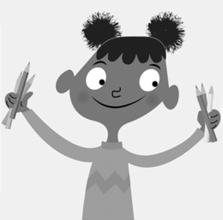 |  | 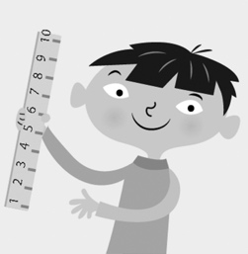 |  | 1 Has she got pencils?  2 Has he got paints?  3 Has he got a lunch box?  4 Has he got a pencil?  5 Has she got a  water bottle?
1 | 2 | 3
 | 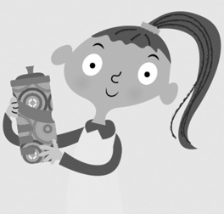
4 | 5
/ 5
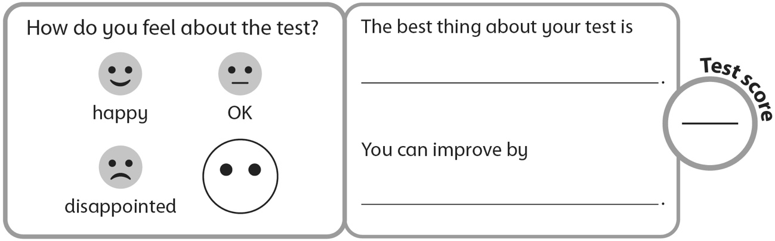
40

